Reg. No: 

Programme : B. E / B. tech
Course Code : CSA4301
Course Name : Internet programming
Problem Statement (Assignment) Max Marks: 100
Field | Content
Assignment Title | Smart Campus Service Management System
Course Outcome(s) – CO | CO1: Develop visually appealing web pages using CSS for layout and style, and create dynamic, interactive functionality with JavaScript.  CO2: Build dynamic web applications using XML, XSLT, and JSP within the MVC paradigm for efficient data handling and presentation.
Bloom’s Taxonomy Level | L3 – Apply | L4 – Analyze | L5 – Evaluate | L6 – Create
SDG Mapping (SDG 1–17) | SDG 9 - Industry, Innovation and Infrastructure, SDG 4 -  Quality Education
Problem Statement
A university currently relies on manual communication such as emails, phone calls, and paper-based records for reporting and resolving campus service issues. This approach makes it difficult to efficiently record complaints, assign requests to the appropriate service personnel, monitor progress, and provide timely status updates to students and faculty.

The university therefore proposes to develop a Smart Campus Service Management System as an integrated web-based application. The system shall enable students and faculty to submit service requests related to laboratory equipment faults, network problems, classroom maintenance, library services, and other technical issues through a web browser. Users should be able to provide relevant details, submit requests, and subsequently track the status of their requests.
The proposed system should demonstrate an integrated client-server web architecture. The client side shall provide an interactive and user-friendly interface using HTML/XHTML, CSS, JavaScript, and DOM. The server side shall process requests using Java Servlets and JSP, following the MVC architecture. XML shall be used for structured data representation, and XSLT shall be used to transform XML data for presentation where appropriate.
Problem Statement
A university can find it challenging to handle complaints related to campus services through traditional means. Students and faculty may submit complaints by email, telephone, in person or in writing. Since these requests are handled through different channels, it can be time-consuming to keep proper records, identify the responsible staff and check the progress of each complaint. Users may also have to call the concerned department multiple times to know if their issue has been addressed.
The university proposes a Smart Campus Service Management System to tackle these issues, providing a centralized web-based platform to manage campus service requests. The system can be used by students and faculty to report problems with laboratory equipment, internet and network services, classroom maintenance, library services and other technical issues. After submitting a request, users can check its current status and track progress until the issue is resolved.
The proposed application will be based on a client-server architecture. HTML/XHTML, CSS, JavaScript and DOM will be used to build the user interface for interactive and user-friendly web pages. The server-based processing will be done in Java Servlets and JSP using MVC architecture. XML will be used to structure and represent information related to services. XSLT will be used, as needed, to transform XML data into suitable forms for display and reporting. The system aims to improve the campus service management in terms of speed, organization, and transparency.
Problem Identification:
From what I see the university faces difficulties in managing campus service complaints through old‑fashioned methods. Students and faculty often use ways to report problems, which makes it hard to keep everything organized and checked.
The major problems identified are:
- Scattered complaints: Service requests come through emails phone calls and written notes of one common platform.
- Difficult record management: Maintaining and searching paper‑based or separate records takes more time and effort.
- Delayed assignment: Service requests may take longer to reach the staff member who will solve the problem.
- Lack of status visibility: Students and faculty may not know whether their request is pending, assigned being processed or completed.
- Poor progress monitoring: Administrators may find it difficult to spot delayed service requests.
- Repeated communication: Users may need to contact the department again to get updates, about their complaints.
- Limited service history: Previous complaints and their resolution details may not be kept in a way.
Proposed Solution
The Smart Campus Service Management System that is being proposed is a web application that is made to make it easier to report and handle problems that happen on campus. It creates a place where students and teachers can send in service requests without having to use emails phone calls or paper forms.
The system will offer the following features:
- User Login: Students and teachers can get into the system safely.
- Service Request Submission: People can send in complaints by choosing the right service type and writing about the problem.
- Service Categories: Requests can be made for things like lab equipment, network problems, classroom repairs, library help and other tech issues.
- Request Assignment: The person in charge can give each request to the person who can handle it.
- Status Tracking: Those who make requests can see if their problem is still waiting has been given to someone is being worked on or is done.
- Progress Updates: The people who handle the requests can change the status and say what has been done far.
- Request History: Previous service requests will be kept so that people and the people in charge can look them up when needed.
- Centralized Management: All service requests will be handled using one web-based tool.

This system will cut down on work make it easier for people and the people who fix problems to talk to each other and make the process for asking for help more organized and clear. It will also help the university deal with problems, on campus.
System Design & Architecture - Data Representation
The Smart Campus Service Management System client gives users a user interface while the Smart Campus Service Management System server receives requests works on them and sends back the needed response.
1. Client Side
The Smart Campus Service Management System client side is the part of the application that users interact with through a web browser.
It uses:
- HTML/XHTML – Creates the structure of web pages and forms.
- CSS – Provides layout, formatting and visual appearance.
- JavaScript – Adds interactive features.
- DOM (Document Object Model) – Lets JavaScript read and change webpage elements.
Students and faculty can use these pages to log in submit service requests and view request status.
2. Server Side
The server takes requests from the browser. Carries out the necessary processing. I find that this part of the system is crucial, for operation. The system uses:
- Java Servlets – Manage requests and run application logic.
- JSP (JavaServer Pages) – Create web pages.
- MVC Architecture – Divides the application into parts for simpler development and maintenance.

3.XML Data Representation
XML (Extensible Markup Language) is used to represent service-request information in a structured format. For example, a service request can be represented as:
<request>
<id>101</id>
<user>Student01</user>
<category>Network</category>
<description>Internet connection problem</description>
<status>Pending</status>
</request>
XML makes the information organized and easy to store, transfer, and process.

4.XSLT Transformation
XSLT stands for Extensible Stylesheet Language Transformations. It is a tool that helps turn XML data into a format that can be shown on a web page or used in a report.
XML Data
↓
XSLT
↓
Formatted Web Page or Report
For example an XML file that holds service request information can be changed using XSLT into an HTML table. This table will show the request ID, the category a description of the request and the current status. The result is easy to read and looks good when displayed in a browser.
The Benefits of the Architecture
- Keeps the user interface separate, from application processing.
- Helps make the application simpler to build and take care of.
- Gives web pages.
- Enables organized storage and sharing of information through XML.
- XSLT can turn XML data into easy to read reports.
- Servlets can handle user requests in a way.
- JSP offers a way to show information dynamically.
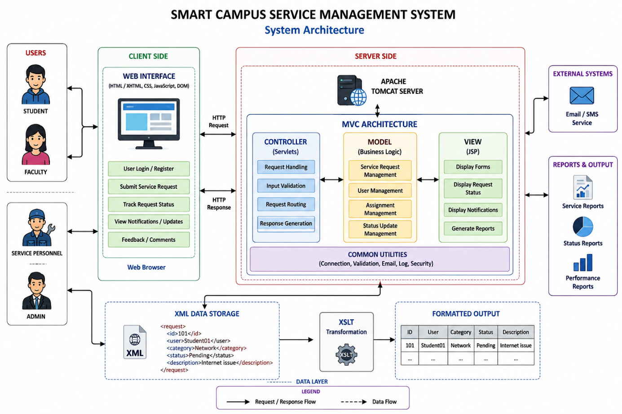

Implementation & Testing :
The Smart Campus Service Management System is built as a web-based platform to handle campus service requests in a way. The Smart Campus Service Management System interface is created with HTML/XHTML and CSS and the Smart Campus Service Management System uses JavaScript and the DOM to add features and to validate input on the client side.
The Smart Campus Service Management System server side runs on Java Servlets and JSP with an MVC design. When a student or faculty member submits a request the Servlet receives the data. Steers the processing flow. The Model handles the service-request operations, such as storing request details assigning the request and updating the status. The JSP pages show the processed information to the user.
XML organizes the service-request information, in a format. XSLT can transform the XML into a formatted view or report. This combination keeps the data organized. Makes the information easier for users and administrators to understand.
Major Functions Implemented
- User Authentication User Authentication ensures that authorized users can log in; User Authentication gives login access to authorized users.
- Request Submission Request Submission lets students and faculty report campus issues; Request Submission makes it easy for students and faculty to submit complaints.
- Category Selection Category Selection sorts complaints into groups such as network, laboratory, classroom or library issues; Category Selection helps group complaints by type.
- Request Assignment Request Assignment helps administrators give requests to the service staff; Request Assignment matches requests with suitable personnel.
- Status Management Status Management keeps track of the progress of each request; Status Management shows how each request is moving forward.
- Request Tracking Request Tracking allows users to see the state of their complaints; Request Tracking lets users check the status of their complaints.
- Notification Notification updates users when the request status changes; Notification sends alerts when the status of a request changes.
- Administration Administration lets authorized staff monitor and manage requests; Administration gives staff the power to oversee and control requests.
- Report Generation Report Generation presents request data in a format; Report Generation shows organized information, about service requests.
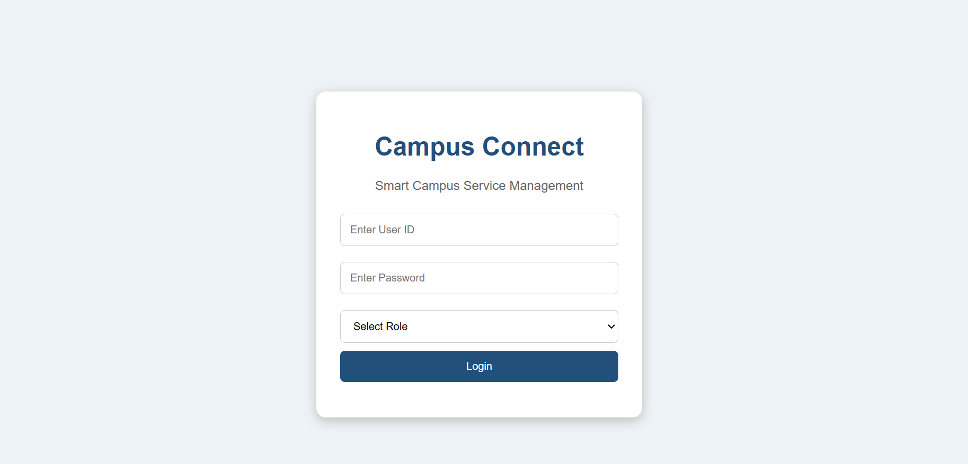
Fig 2 : Login page

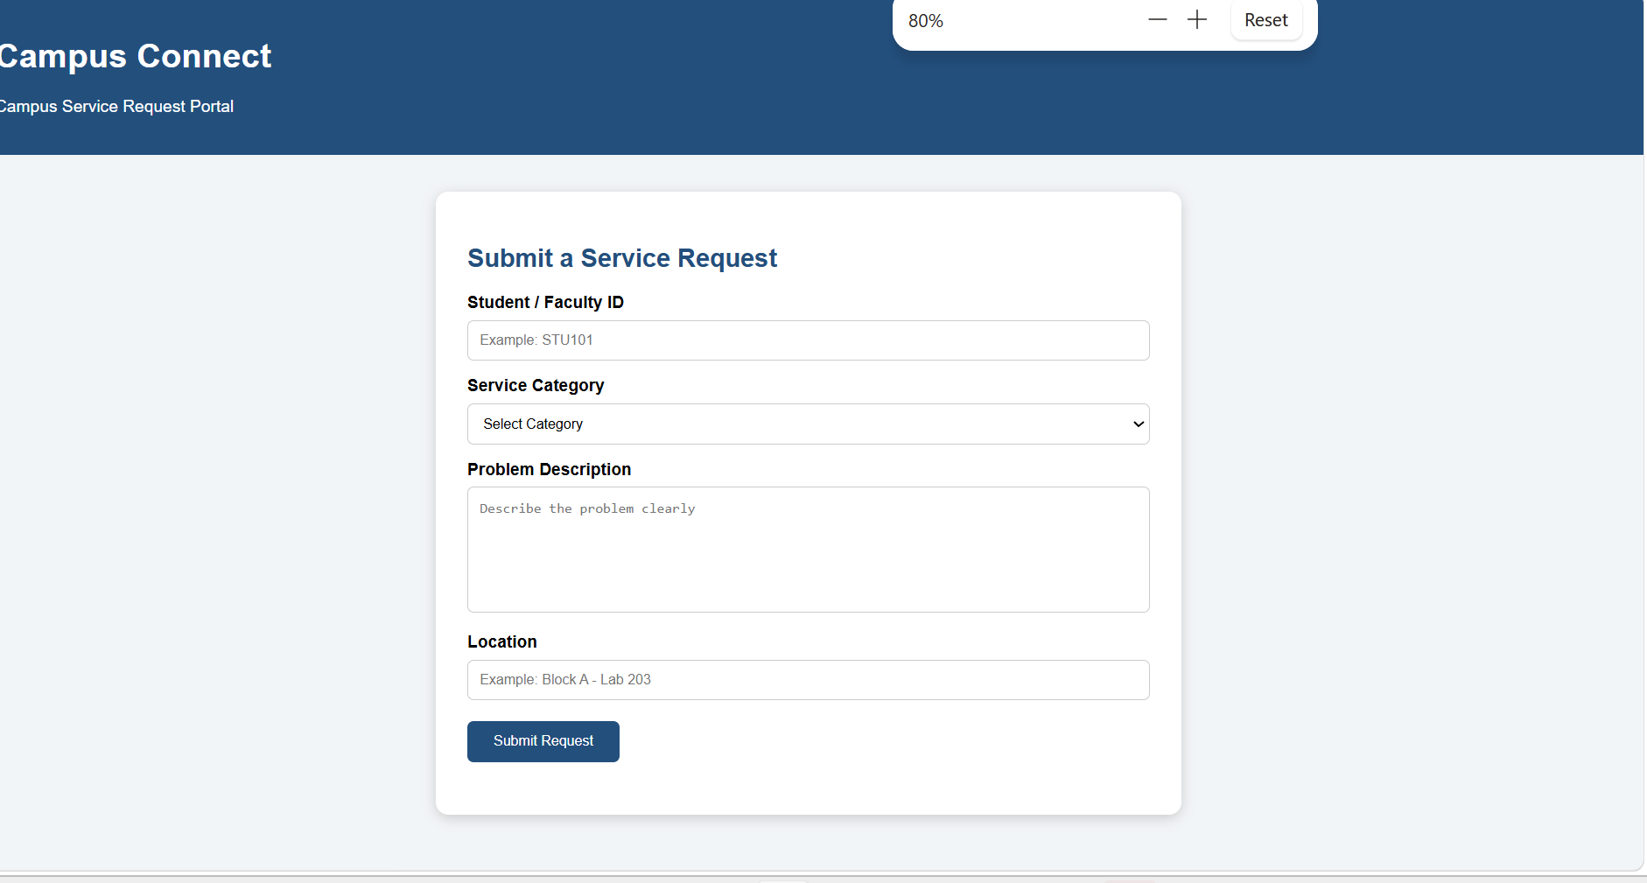
Fig 3 : Request Portal

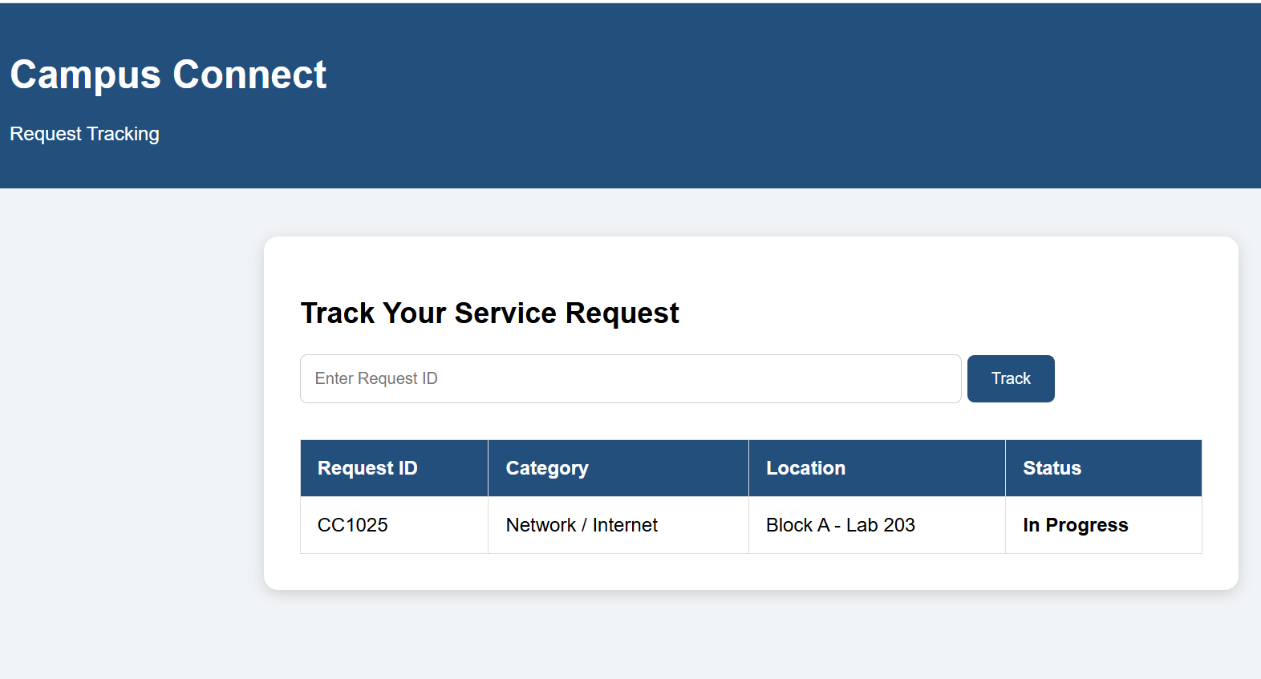
Fig 4 : Request Tracking

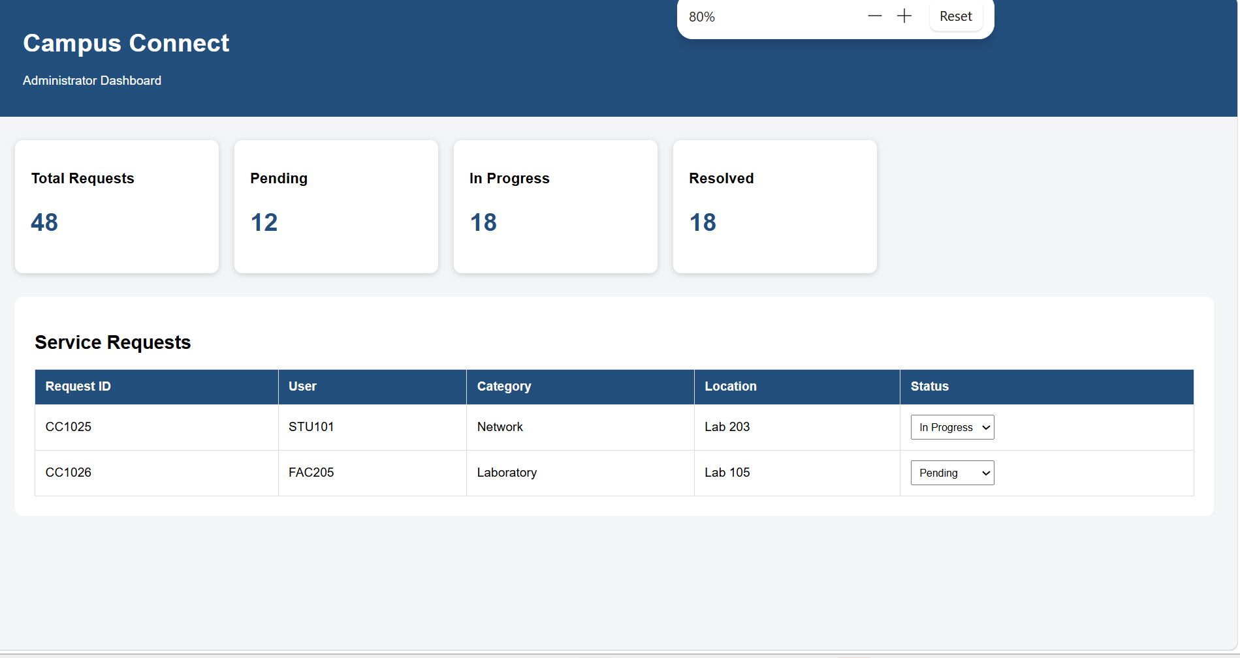
Fig 5 : DashBoard

Testing
Testing is carried out to check whether each important function of the application produces the expected result. The system is tested using different user inputs, including valid and invalid information. The testing process helps identify input errors, processing problems, and incorrect status updates before the system is used in practice.
Test Cases
Test ID | Test Performed | Expected Outcome | Result
TC01 | Login with correct credentials | User is taken to the appropriate dashboard | Pass
TC02 | Login with incorrect credentials | System rejects the login and shows an error | Pass
TC03 | Submit a complete service request | New request is successfully created | Pass
TC04 | Submit a request without required information | System asks the user to provide the missing details | Pass
TC05 | View an existing request | Request details and current status are displayed | Pass
TC06 | Assign a request to service personnel | Selected personnel receives the assigned request | Pass
TC07 | Change the request status | Updated status is reflected in the system | Pass
TC08 | Generate a service report | Relevant request information is displayed in report form | Pass
4.3 Test Results
The tests that were done show that the main functions of the Smart Campus Service Management System work the way they are supposed to. The app works for user login reporting problems assigning requests, checking progress, changing status and making reports. So the system that was built offers a digital way to deal with service requests on campus and cuts down on the need, for scattered and manual communication.
5.1 Functional Requirements
- The functional requirements specify the activities that the Campus Connect application must support.
- The user should be able to access Campus Connect through a login page.
- The user should be able to create a service request by entering the needed information.
- The application should provide categories for different campus‑related problems.
- Each request should receive an identification number for future reference.
- The user should be able to view the details of requests submitted earlier.
- The administrator should be able to examine received requests.
- Requests should be assignable to the staff member for handling the particular issue.
- Assigned personnel should be able to record changes in the progress of a request.
- The user should be able to see the status of their requests.
- The application should retain completed request information for use.
5.2 Non-Functional Requirements
The following qualities are expected from the proposed application:
- Ease of Use: The pages should have a layout so that users can complete tasks without difficulty.
- Response Time: User actions such as submitting or viewing a requst should produce results within a time.
- Security: Access to service‑management features should be restricted to authorized users.
- Accuracy: Request information and status updates should be recorded correctly.
- Maintainability: The use of MVC should keep presentation, processing and data handling separate making future changes easier.
- Browser Support: The application should be accessible, through modern web browsers.
STG Goals
The project supports SDG 9 by replacing inefficient manual methods of reporting campus service issues with a centralized digital service-management infrastructure. This new system makes it easier to record complaints assign them to the teams monitor progress and resolve problems in a timely way. It uses an integrated web-based platform that brings all these steps together into one process.

SDG 4 :
The project helps advance SDG 4 by giving students and faculty an accessible interface to submit service requests and track their status. When users can report issues quickly and see how they are being handled it leads to responses and better support. This improved access, to campus services helps create an effective learning environment, where students and staff can focus more on teaching and studying.

Requirement Analysis
The existing system depends on emails, telephone calls, and paper records to communicate campus-related problems. These methods can result in delayed responses, incomplete information, difficulty in assigning complaints to the correct personnel, and limited visibility of request status. Therefore, the proposed system requires a centralized digital platform that can capture service requests, organize complaint information, assign tasks to responsible personnel, and provide status updates throughout the resolution process.
Client Interface Development
The client interface will be built as an easy‑to‑use web application. The client interface will let students and faculty enter the needed details about problems such as lab equipment failures, network connectivity issues, classroom maintenance, library services and other technical concerns. The client interface will also let users view their submitted requests and see how those requests are progressing.

The client side will be created with HTML, CSS, JavaScript and the DOM to make web pages that feel smooth to use. The server side will use Java Servlets and JSP following the MVC model to keep the presentation the logic and the data handling separate. XML will hold data and XSLT can transform XML into a presentation format when needed.
This integrated client‑server architecture will give an efficient way to manage campus services and reduce the need, for manual communication.
Assessment Criterion | CO Mapping | Weightage / Marks
Problem understanding & formulation | CO1 | 10
Application of course/domain knowledge | CO2 | 20
Solution methodology / design / implementation | CO3 | 20
Use of appropriate modern tools / techniques | CO4 | 10
Results, testing & validation | CO4 / CO5 | 15
Analysis, trade-offs & justification | CO5 | 15
Broader considerations / professional responsibility, where applicable | CO5 | 5
Technical documentation & reflection | CO1–CO5 | 5
TOTAL |  | 100

Performance Level | CO Attainment Percentage | Interpretation
Level 3 | ≥ 70% | CO Attained
Level 2 | 60–69% | CO Moderately Attained
Level 1 | 50–59% | CO Minimally Attained
Level 0 | < 50% | CO Not Attained

Code of Conduct
I SRAVANTHI K (192372127) (Name / Reg. No.) certify that this submission is my original work and that I have adhered to the guidelines specified for this assessment. I understand that any violation of academic-integrity rules will result in disciplinary action.

Signature of the Student: SRAVANTHI K
_____________________  Faculty In-charge  Name: DR . MARINE CLAUDE  Date: 2/9/2026 | _____________________  Course Coordinator  Name:  Date: | _____________________  Head of Department  Name:  Date:

